**BP315 Business Sub-Process Design Document**

**Qualtrics Sales Customer Experience**

**Cross Industry/Customer Insight and Growth**

**SAP – Cloud for Customer**

Table of Contents

1 Overview 3

1.1 Change History 3

1.2 RASCI 3

1.3 Approval Detail 3

1.4 Other Related Documents 4

2 Business Process Overview 4

2.1 High level requirements 4

2.2 Key Value Drivers for the Business Process 4

2.3 Leading Practice Inputs 5

3 Business Sub-Process Description 5

3.1 Business Sub-Process diagram 5

4 Sub Process Activities 5

4.1 Activity List 6

4.2 Inbound Communication 7

4.3 Outbound Communication 7

4.4 Test Conditions 8

5 Sub-Process Variation 8

5.1 Business Unit Led 8

5.2 Geography/Legal Entity Led 8

6 Role Definition & Organisational Impact 8

6.1 Role/Skill Class Inventory 8

6.2 Role Summary 8

6.3 Organizational Impact 9

7 Process Fitness & Gap Analysis 9

7.1 Process Fitness 9

7.2 Gap Analysis 9

8 RICEFW 10

8.1 Reports 10

8.2 Interfaces (Inbound / Outbound) 10

8.3 Conversions 10

8.4 Enhancements 11

8.5 Forms 11

8.6 Workflows 11

9 Integration Points 13

9.1 Integration Issues 13

9.2 Other issues 13

# Overview

Qualtrics is the experience management (XM) platform used to close experience gaps and deliver breakthrough results. The XM Platform makes it simple for any organization to collect, understand, and take action on experience data (X-data)—the beliefs, emotions, and sentiments of customers and employees.

Qualtrics turn every customer interaction into meaningful insights with iQ Directory, which allows you to monitor and optimize each customer’s experience over time, across every touchpoint, and every channel.

This business scenario showcase how companies can make use of effective Qualtrics functionalities to capture customer feedback on Online website performance, checkout process etc.

## Change History

|  |  |  |  |  |
| --- | --- | --- | --- | --- |
| Ver. | Date | Summary of Changes | Author | Transport Number |
| V1.0 | 05.12.2019 | Initial document | Karthik Para | N/A |
| V1.1 | 19.03.2020 | Updated document as per new template | Praveen Dadhich | N/A |
|  |  |  |  |  |

## RASCI

|  |  |  |  |
| --- | --- | --- | --- |
| RASCI | Role | Name | Phone |
| N/A | N/A | N/A | N/A |
|  |  |  |  |
|  |  |  |  |

R: Responsible; A: Accountable; S: Support; C: Contribute; I: Information;

## Approval Detail

|  |  |  |  |
| --- | --- | --- | --- |
| Review # | Date | Name & Position of Approver | Signature |
| N/A | N/A | N/A | N/A |
|  |  |  |  |

## 

## Other Related Documents

|  |  |
| --- | --- |
| Related Document | Comment |
| BP310_C4C_Qualtrics Sales Customer Experience | Business Process |
| TE586_C4C_Qualtrics Sales Customer Experience | Test Script |
| AP322_C4C_Qualtrics Sales Customer Experience | Configuration Guide |
|  |  |

# Business Process Overview

Qualtrics is a powerful online survey tool that allows to build surveys, distribute surveys and analyze responses. Dashboards are created to represent the experience data and operational data using widgets in an interactive format.

With Qualtrics surveys it is possible to seamlessly connect and communicate with customers. Qualtrics leads can be used to increase customer loyalty and retention. If it is paired with increased net promoter score it will help in building a company that will stay ahead of its competitors.

## High level requirements

Below are the high-level requirements for this scenario

Creating Qualtrics sales survey to capture feedback from customers.

Define conditions on which actions can be triggered to notify sales/support team.

Add/Upload contacts master data in Qualtrics system.

Distribution of survey to customers via email.

Analyze the customer responses with various iQ’s provided by Qualtrics.

Create Qualtrics dashboard from the data consolidated.

## Key Value Drivers for the Business Process

Solution brings the following values to business:

It helps business to get straight to the issues that matter to customers with dynamic data collection tools that adapt intelligently to feedback in real-time.

It helps business to turn every customer interaction into meaningful insights with iQ Directory, which allows one to monitor and optimize each customer’s experience over time, across every touchpoint, and every channel.

This template enables business in starting conversations with customers which are already lost and not happy with business.

## Leading Practice Inputs

This scenario is related to Intelligent Experience Management pillar of our Golden Template which talks about administering surveys to find the gaps and work on steps to improve the processes.

Qualtrics turn every customer interaction into meaningful insights with iQ directory.

Qualtrics manages brand experience, customer experience, employee experience and product experience

Qualtrics dashboards pull data sources into visualizations called widgets -data representation in dashboard.

# Business Sub-Process Description

The sub-process describe how business can create survey and distribute to target audience and request feedback to find gap in process and leverage the same to bridge the gap.

## Business Sub-Process diagram

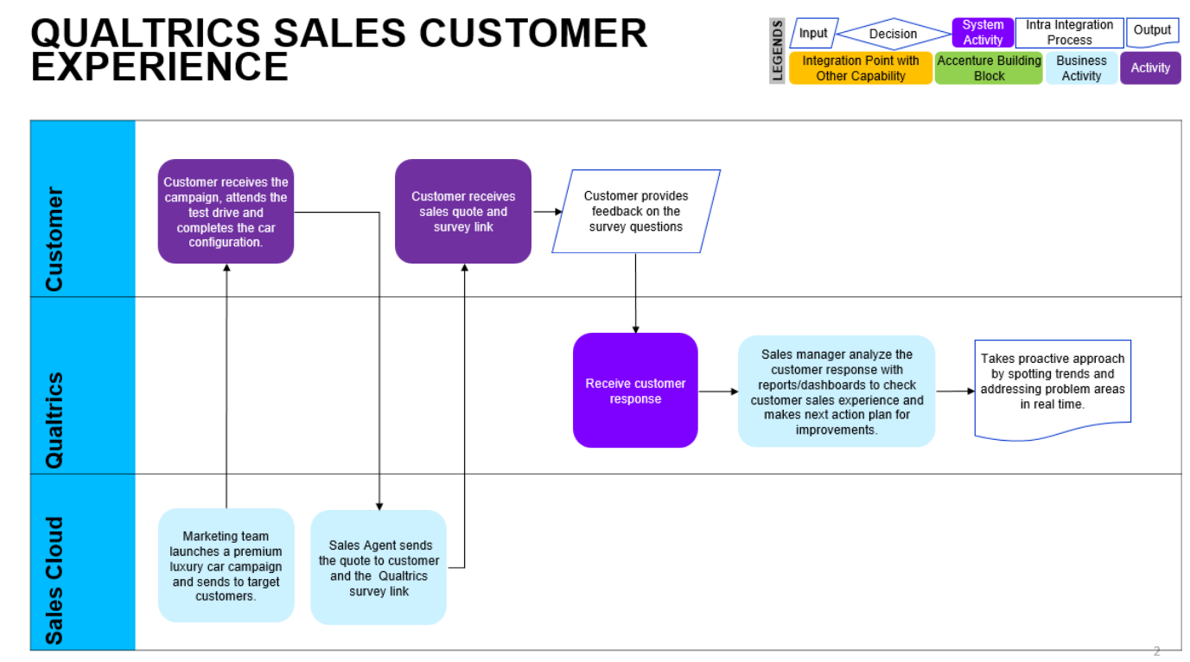

# Sub Process Activities

**Creating Qualtrics survey**

Qualtrics has provided pre-build template to capture standard business processes and segregated based on key aspects like Net promotors score, Customer Satisfaction, Customer Effort score etc. Survey and dashboard can be created manually or with the help of template and with best practise, based on the requirements these survey questions can be modified. Once survey is finalized and published, this can be rereviewed with survey preview option.

**Add/Upload of contacts master data**

Contact lists are mailing lists used to distribute survey invitations, they contain each contact’s name, email address, embedded data etc. Contact lists are managed on the Contacts page under contact directories.

**Distribution of survey to customers**

We can distribute survey to targeted audience via several channel available in Qualtrics. For example, through email, QR code, personal links, sms, social media etc.

**Customer response to survey**

Customers receives personalized email to take survey and fill in answers/comments to question. If customer press submit button, survey responses are captured and stored in Qualtrics database. And if customer does not press submit button or terminate survey in between, response will be captured as partial response and stored in Qualtrics database.

**Analyze the customer responses with various iQ features**

After response collection, survey response can be analysed using pre-built IQs and Deep Algorithms. One can even massage the data to see impact on business process from different angles.

For example: by creating new variable and linking/relating to old variables or bucketing old variables to create new variable of different data type.

Available IQ’s are:

Text IQ

Stats IQ

Predict IQ etc.

Qualtrics provide standard reports for survey and can be customized to achieve as per desire.

**Create Qualtrics Dashboard**

Qualtrics dashboards are represent the survey data in the effective way with the help of widgets. Dashboards pull Data Sources into visualizations called widgets. Dashboard pages provide a thematic design framework to organize the widgets in meaningful ways. As we have used pre-build template, dashboard comes as part of it. Qualtrics provided dashboard which can very easily find the gap between business process and customer expectation in no time.

## Activity List

It maps to the BP317, Activity definition document if applicable for the project & also has references in the process/sub process diagram.

|  |  |  |  |  |
| --- | --- | --- | --- | --- |
| Name | Description | Transaction Code,  if relevant | Roles involved | Regulatory /Other Controls |
| Qualtrics survey creation/distribution | Create a survey and distribute to customer to capture the responses. | N/A | Agent/manager | N/A |
| Customer response on survey | Customer submits the responses based on sales/service journey experience | N/A | Customer | N/A |
| Analysis of customer responses and dashboard creation | Analyse the customer responses with various iQ techniques and create a dashboard to represent data in widgets format | N/A | Agent/manager | N/A |

## Inbound Communication

The Inbound Communication needs to be specifically documented for the client specific situation, like interfacing with external systems, workflow, form & Medium of communication.

|  |  |  |  |  |
| --- | --- | --- | --- | --- |
| Activity | Type (email, form, handoff, etc) | Automatic/Manual | Source | Description |
| N/A | N/A | N/A | N/A | N/A |
|  |  |  |  |  |
|  |  |  |  |  |
|  |  |  |  |  |
|  |  |  |  |  |

## Outbound Communication

The Outbound Communication needs to be specifically documented for the client specific situation, like interfacing with external systems, workflow, form & Medium of communication.

|  |  |  |  |  |
| --- | --- | --- | --- | --- |
| Activity | Type (email, form, handoff, etc) | Automatic/Manual | Source | Description |
| N/A | N/A | N/A | N/A | N/A |
|  |  |  |  |  |

## 

## Test Conditions

This section captures test conditions for this sub process for the any specific client requirements. Generic test conditions for this sub process will be within the AAES test scripts.

|  |  |  |
| --- | --- | --- |
| Number | Test Condition – Action | Expected Result |
| 1 | Available under test script document | TE586_C4C_Qualtrics Sales Customer Experience |
|  |  |  |

# Sub-Process Variation

## Business Unit Led

N/A

## Geography/Legal Entity Led

N/A

# Role Definition & Organisational Impact

The content in this section will serve as input for the training and performance support team’s deliverables.

## Role/Skill Class Inventory

|  |  |  |
| --- | --- | --- |
| Role | Skills | Knowledge |
| Administrator | Qualtrics | Qualtrics configurations |
| Manager | Qualtrics | Qualtrics survey process |
|  |  |  |

## Role Summary

|  |  |  |
| --- | --- | --- |
| Role | List of Steps | SAP Transaction |
| N/A | N/A | N/A |
|  |  |  |

## 

## Organizational Impact

|  |  |  |  |  |
| --- | --- | --- | --- | --- |
| Reference # | Impact Description | Impact (H/M/L) | Impact Type | Impacted Groups |
| N/A | N/A | N/A | N/A | N/A |

# 

# Process Fitness & Gap Analysis

## Process Fitness

|  |  |  |  |  |
| --- | --- | --- | --- | --- |
| Req ID | Short Description | Long Description | Req. Type | Accenture Reusable Assets |
| N/A | N/A | N/A | N/A | N/A |
|  |  |  |  |  |

## 

## Gap Analysis

|  |  |  |  |  |  |  |
| --- | --- | --- | --- | --- | --- | --- |
| Country/ Region/ Business Impacted | Gap Description | Legal Req. (Y/N) | Magnitude of Impact (L/M/H) | Solution Type | RICEFW No. | Ref. to Req. id. |
| N/A | N/A | N/A | N/A | N/A | N/A | N/A |
|  |  |  |  |  |  |  |

# RICEFW

## Reports

|  |  |  |  |  |  |
| --- | --- | --- | --- | --- | --- |
| Client XYZ  RICEFW # | Report Description | Complexity (H/M/L) | Comments | Use from myConcerto/ARTL (New/Rework/Rep) | Ref # from RICEFW inventory |
| N/A | N/A | N/A | N/A | N/A | N/A |
|  |  |  |  |  |  |

## Interfaces (Inbound / Outbound)

|  |  |  |  |  |  |
| --- | --- | --- | --- | --- | --- |
| Client XYZ  RICEFW # | Interface Description | Complexity  (H/M/L) | Comments | Use from myConcerto/ARTL (New/Rework/Rep) | Ref # from RICEFW inventory |
| N/A | N/A | N/A | N/A | N/A | N/A |
|  |  |  |  |  |  |

## 

## Conversions

|  |  |  |  |  |  |
| --- | --- | --- | --- | --- | --- |
| Client XYZ  RICEFW # | Conversion Description | Complexity  (H/M/L) | Comments | Use from myConcerto/ARTL (New/Rework/Rep) | Ref # from RICEFW inventory |
| N/A | N/A | N/A | N/A | N/A | N/A |
|  |  |  |  |  |  |

## 

## Enhancements

|  |  |  |  |  |  |
| --- | --- | --- | --- | --- | --- |
| Client XYZ  RICEFW # | Enhancement Description | Complexity  (H/M/L) | Comments | Use from myConcerto/ARTL (New/Rework/Rep) | Ref # from RICEFW inventory |
| N/A | N/A | N/A | N/A | N/A | N/A |
|  |  |  |  |  |  |

## 

## Forms

|  |  |  |  |  |  |
| --- | --- | --- | --- | --- | --- |
| Client XYZ RICEFW # | Form Description | Complexity (H/M/L) | Comments | Use from myConcerto ARTL (New/Rework/Rep) | Ref # from RICEFW inventory |
| N/A | N/A | N/A | N/A | N/A | N/A |
|  |  |  |  |  |  |

## 

## Workflows

|  |  |  |  |  |  |
| --- | --- | --- | --- | --- | --- |
| Client XYZ RICEFW # | Workflow Description | Complexity (H/M/L) | Comments | Use from myConcerto (New/Rework/Rep) | Ref # from RICEFW inventory |
| N/A | N/A | N/A | N/A | N/A | N/A |
|  |  |  |  |  |  |

# Integration Points

Generic Integration touch points have been highlighted in this section. It covers dependencies or prerequisites arising from other processes or sub processes. This information should lead to cross functional discussions between different work streams to sort out the interdependencies.

## Integration Issues

|  |  |  |  |  |
| --- | --- | --- | --- | --- |
| Issue # | Issue Description | Impact | Status | Resolution |
| N/A | N/A | N/A | N/A | N/A |
|  |  |  |  |  |

## Other issues

|  |  |  |  |  |
| --- | --- | --- | --- | --- |
| Issue # | Issue Description | Impact | Status | Resolution |
| N/A | N/A | N/A | N/A | N/A |
|  |  |  |  |  |

#### Revision History

|  |  |  |  |
| --- | --- | --- | --- |
| Date | Version | Description | Author |
| 05.12.2019 | V1.0 | Business Sub-Process Design Document  Qualtrics Sales Customer Customer Experience | Karthik Para |
| 19.03.2020 | V1.1 | Updated document as per new template | Praveen Dadhich |
|  |  |  |  |